# End of topic quiz

# Topic C4: Predicting chemical reactions

## Instructions and answers for teachers

These instructions cover the learner activity section which can be found on page 9. This end of topic quiz supports OCR GCSE (9–1) Combined Science A (J250), Topic C4.

**When distributing the activity section to the learners either as a printed copy or as a Word file you will need to remove the teacher instructions section.**

### The Activity

This end of topic quiz comprises of 40 marks covering a range of question types. The quiz starts with some multiple choice questions and them moves on to some short answer questions and then finally on to some longer answer questions.

The question worksheet can be used to consolidate understanding at the end of teaching the chapter, to revisit and refresh knowledge at a later point in the course, or during exam preparation.

### Learning Outcomes

This end of topic quiz relates to the specification learning outcomes in Topic C4: Predicting chemical reactions. The quiz covers the following topics:

C4.1 Predicting chemical reactions

### Topic: C4 of J250 ­– Answers

**Total marks: 40**

1. Which group of elements in the Periodic Table are unreactive? **[1 mark]**

|  |  |  |
| --- | --- | --- |
| **A** | Group 7 |  |
| **B** | Group 1 |  |
| **C** | Group 0 |  |
| **D** | Group 4 |  |

Your answer

**C**

1. Which of the statements is a property of Group 0? **[1 mark]**

|  |  |  |
| --- | --- | --- |
| **A** | High density |  |
| **B** | High boiling points |  |
| **C** | Low boiling points |  |
| **D** | Malleable |  |

Your answer

**C**

1. What colour flame is produced when potassium reacts with water? **[1 mark]**

|  |  |  |
| --- | --- | --- |
| **A** | Blue |  |
| **B** | Lilac |  |
| **C** | Orange |  |
| **D** | Red |  |

Your answer

**B**

1. Which of the statements is a trend of Group 7 elements? **[1 mark]**

|  |  |  |
| --- | --- | --- |
| **A** | Elements change state from liquid to gas as you go down the group |  |
| **B** | Melting and boiling points increase as you go down the group |  |
| **C** | Melting and boiling points decrease as you go down the group |  |
| **D** | Colour of the elements get lighter as you go down the group |  |

Your answer

**B**

1. What colour is astatine, a Group 7 element? **[1 mark]**

|  |  |  |
| --- | --- | --- |
| **A** | Black |  |
| **B** | Lilac |  |
| **C** | Purple |  |
| **D** | Red |  |

Your answer

**A**

1. Fluorine reacts with iron wool to form iron(III)fluoride.

Which equation is the balance symbol equation for this reaction? **[1 mark]**

|  |  |  |
| --- | --- | --- |
| **A** | F2 + Fe FeF3 |  |
| **B** | F + Fe FeF |  |
| **C** | 3F2 + 2Fe 2FeF3 |  |
| **D** | 3F + Fe FeF3 |  |

Your answer

**C**

1. Group 7 elements are also known as the halogens.

|  |  |  |  |
| --- | --- | --- | --- |
| **(a)** | **(i)** | They react with Group 1 metals to produce white salts.  Write the word equation for the reaction of lithium with chlorine. **[1 mark]** | |
|  |  | Lithium + chlorine lithium chloride ✓ | |
|  |  |  |  |
|  | **(ii)** | Write the balanced symbol equation for this reaction. **[2 marks]** | |
|  |  | 2Li + C*l* 2 2LiC*l* ✓ ✓ | |
|  |  |  |  |
|  | **(iii)** | What happens to the outer shell of electrons of chlorine when it reacts with lithium? **[2 marks]** | |
|  |  | Gains **1** electron ✓  **Complete** outer shell of electrons/forms -1 ion ✓ | |
|  |  |  |  |
| **(b)** | **(i)** | Write the word and balanced symbol equation for the reaction of chlorine with sodium bromide. **[2 marks]** | |
|  |  | Sodium bromide + chlorine sodium chloride + bromine ✓  2NaBr + C*l*2 2NaC*l* + Br2 ✓ | |
|  |  |  |  |
|  | **(ii)** | What is the type of reaction shown in **(b)(i)** and why does it happen? **[2 marks]** | |
|  |  | Displacement ✓  Because  Chlorine is more reactive than bromine/bromine less reactive than chlorine ✓ | |

|  |  |  |  |  |  |  |  |  |  |  |  |  |
| --- | --- | --- | --- | --- | --- | --- | --- | --- | --- | --- | --- | --- |
| **(c)** |  | Group 7 elements react with hydrogen. The results are in the table below.   | **Elements** | **Reaction with hydrogen** | | --- | --- | | Bromine | Mild explosion with a flame | | Iodine | Only combine partially | | Fluorine | Combines explosively | | Chlorine | Explode if exposed to sunlight or flame |   Using the information above put the elements in order from most reactive to least reactive. **[1 mark]** |
|  |  | Fluorine  Chlorine  Bromine  Iodine ✓ |

1. The most well know Group 0 element is helium.

|  |  |  |  |
| --- | --- | --- | --- |
| **(a)** | **(i)** | What are the general properties of Group 0 elements? **[3 marks]** | |
|  |  | **Any three from:**  Unreactive ✓  Non-metals ✓  Exist as single atoms ✓  Colourless ✓ | |
|  |  |  |  |
|  | **(ii)** | Why do Group 0 elements have these properties? **[1 mark]** | |
|  |  | Full outer shell of electrons ✓ | |
|  |  |  |  |
| **(b)** | **(i)** | Helium is often used in balloons. Which property makes helium useful in balloons? [**1 mark]** | |
|  |  | Density ✓ | |
|  |  |  |  |
|  | **(ii)** | Using knowledge of properties and reactivity, why is helium used in airships? **[3 marks]** | |
|  |  | Not reactive/not flammable ✓  Gaseous state ✓  Low density/less dense than air ✓ | |

1. Group 1 is located on the left side of the Periodic Table. The elements have similar properties.

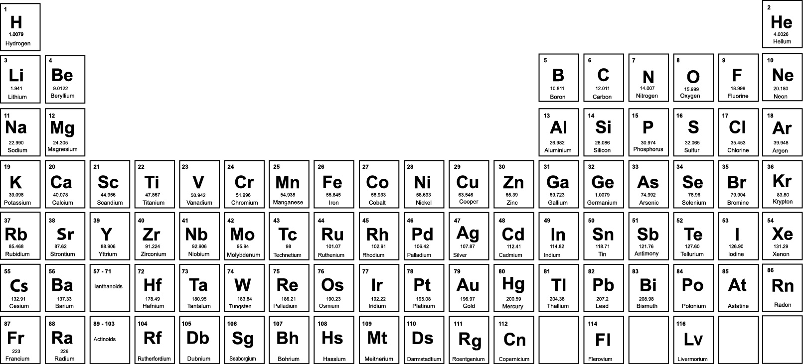

|  |  |  |  |
| --- | --- | --- | --- |
| **(a)** | **(i)** | How do Group 1 metals react with oxygen? **[1 mark]** | |
|  |  | Tarnish/from shiny to dull/not shiny/rapidly ✓ | |
|  |  |  |  |
|  | **(ii)** | Why is rubidium more reactive than lithium? **[2 marks]** | |
|  |  | **Any two from:**  (1 electron in outer shell) further away from nucleus means easy to lose  electron ✓  More reactive elements lose electrons easier than others ✓  Atoms further down the group are more reactive ✓ | |
|  |  |  |  |
| **(b)** | **(i)** | Jon does some experiments with group 1 elements. He drops them into water. What does Jon observe when sodium is added to water? **[3 marks]** | |
|  |  | Fizzing/gas produced/bubbles/hydrogen produced ✓  Hissing or sound or noise as gas bubbles produced (and burst) ✓  Orange flame ✓ | |
|  |  |  |  |
|  | **(ii)** | Sodium reacts with water to produce hydrogen gas and sodium hydroxide solution.  Complete the balanced symbol equation for this reaction. **[2 marks]** | |
|  |  | ......**2**.....Na + .....**2H2O**... 🡪 .......**(1)**.......H2 +……**2NaOH**.......... ✓✓ | |

1. Raj adds some metals to metal salts.

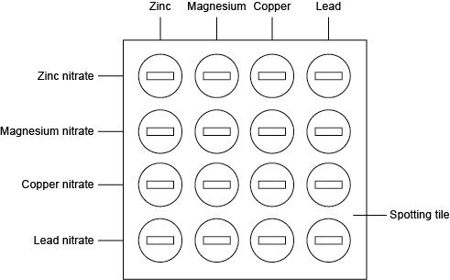

Raj records her results in the table below.

|  | **Zinc** | **Magnesium** | **Copper** | **Lead** |
| --- | --- | --- | --- | --- |
| **Zinc nitrate** | No change | Colour change | No change | No change |
| **Magnesium nitrate** | No change | No change | No change | No change |
| **Copper nitrate** | Colour change | Colour change | No change | Colour change |
| **Lead nitrate** | Colour change | Colour change | No change | No change |

|  |  |  |  |
| --- | --- | --- | --- |
| **(a)** |  | The solution of zinc nitrate does not change colour when zinc is added. Why does no change happen? **[1 mark]** | |
|  |  | (Same metal) so no displacement reaction ✓ | |
|  |  |  |  |
| **(b)** |  | Why is there no change when copper is added to magnesium nitrate? **[2 marks]** | |
|  |  | Copper less reactive than magnesium ✓  Therefore cannot displace magnesium ✓ | |
|  |  |  |  |
| **(c)** |  | What is the order of reactivity of the metals? Start with the most reactive. **[2 marks]** | |
|  |  | Magnesium  Zinc  Lead  Copper ✓✓ | |
|  |  |  |  |
| **(d)** |  | What would happen if iron is added to each of the metal salt solutions? Give a reason for your answer. **[3 marks]** | |
|  |  | Iron will displace/react with lead and copper ✓  Iron will not displace/react with magnesium and zinc ✓  Iron is more reactive than iron and copper **but** less reactive than magnesium and zinc ✓ | |

This formative assessment resource has been produced as part of our free GCSE teaching and learning support package. All the GCSE teaching and learning resources, including delivery guides, topic exploration packs, lesson elements and more are available on the qualification webpages.

If you are looking for examination practice materials, you can find the Sample Assessment Materials (SAMs) on the qualification webpage: [Combined Science A (9–1).](http://www.ocr.org.uk/qualifications/gcse-gateway-science-suite-combined-science-a-j250-from-2016/)

**OCR Resources**: *the small print*OCR’s resources are provided to support the delivery of OCR qualifications, but in no way constitute an endorsed teaching method that is required by the Board, and the decision to use them lies with the individual teacher. Whilst every effort is made to ensure the accuracy of the content, OCR cannot be held responsible for any errors or omissions within these resources.  
© OCR 2016 - This resource may be freely copied and distributed, as long as the OCR logo and this message remain intact and OCR is acknowledged as the originator of this work.

OCR acknowledges the use of the following content: Periodic table, Shutterstock/Charobnica

Please get in touch if you want to discuss the accessibility of resources we offer to support delivery of our qualifications: [resources.feedback@ocr.org.uk](mailto:resources.feedback@ocr.org.uk)

We’d like to know your view on the resources we produce. By clicking on ‘[Like](mailto:resources.feedback@ocr.org.uk?subject=I%20liked%20the%20GCSE%20(9-1)%20Gateway%20Science%20Combined%20Science%20A%20End%20of%20Topic%20Quiz%20(Topic%20C4:%20Predicting%20chemical%20reactions))’ or ‘[Dislike](mailto:resources.feedback@ocr.org.uk?subject=I%20liked%20the%20GCSE%20(9-1)%20Gateway%20Science%20Combined%20Science%20A%20End%20of%20Topic%20Quiz%20(Topic%20C4:%20Predicting%20chemical%20reactions))’ you can help us to ensure that our resources work for you. When the email template pops up please add additional comments if you wish and then just click ‘Send’. Thank you.

If you do not currently offer this OCR qualification but would like to do so, please complete the Expression of Interest Form which can be found here: [www.ocr.org.uk/expression-of-interest](http://www.ocr.org.uk/expression-of-interest)

Looking for a resource? There is now a quick and easy search tool to help find free resources for your qualification:   
[www.ocr.org.uk/i-want-to/find-resources/](http://www.ocr.org.uk/i-want-to/find-resources/)

# 

# End of topic quiz

# Topic C4: Predicting chemical reactions

## Learner Activity

### Topic: C4 of J250

**Total marks: 40**

1. Which group of elements in the Periodic Table are unreactive? **[1 mark]**

|  |  |  |
| --- | --- | --- |
| **A** | Group 7 |  |
| **B** | Group 1 |  |
| **C** | Group 0 |  |
| **D** | Group 4 |  |

Your answer

1. Which of the statements is a property of Group 0? **[1 mark]**

|  |  |  |
| --- | --- | --- |
| **A** | High density |  |
| **B** | High boiling points |  |
| **C** | Low boiling points |  |
| **D** | Malleable |  |

Your answer

1. What colour flame is produced when potassium reacts with water? **[1 mark]**

|  |  |  |
| --- | --- | --- |
| **A** | Blue |  |
| **B** | Lilac |  |
| **C** | Orange |  |
| **D** | Red |  |

Your answer

1. Which of the statements is a trend of Group 7 elements? **[1 mark]**

|  |  |  |
| --- | --- | --- |
| **A** | Elements change state from liquid to gas as you go down the group |  |
| **B** | Melting and boiling points increase as you go down the group |  |
| **C** | Melting and boiling points decrease as you go down the group |  |
| **D** | Colour of the elements get lighter as you go down the group |  |

Your answer

1. What colour is astatine, a Group 7 element? **[1 mark]**

|  |  |  |
| --- | --- | --- |
| **A** | Black |  |
| **B** | Lilac |  |
| **C** | Purple |  |
| **D** | Red |  |

Your answer

1. Fluorine reacts with iron wool to form iron(III)fluoride.

Which equation is the balance symbol equation for this reaction? **[1 mark]**

|  |  |  |
| --- | --- | --- |
| **A** | F2 + Fe FeF3 |  |
| **B** | F + Fe FeF |  |
| **C** | 3F2 + 2Fe 2FeF3 |  |
| **D** | 3F + Fe FeF3 |  |

Your answer

1. Group 7 elements are also known as the halogens.

|  |  |  |  |
| --- | --- | --- | --- |
| **(a)** | **(i)** | They react with Group 1 metals to produce white salts.  Write the word equation for the reaction of lithium with chlorine. **[1 mark]** | |
|  |  |  | |
|  |  |  |  |
|  | **(ii)** | Write the balanced symbol equation for this reaction. **[2 marks]** | |
|  |  |  | |
|  |  |  |  |
|  | **(iii)** | What happens to the outer shell of electrons of chlorine when it reacts with lithium? **[2 marks]** | |
|  |  |  | |
|  |  |  |  |
| **(b)** | **(i)** | Write the word and balanced symbol equation for the reaction of chlorine with sodium bromide. **[2 marks]** | |
|  |  |  | |
|  |  |  |  |
|  | **(ii)** | What is the type of reaction shown in **(b)(i)** and why does it happen? **[2 marks]** | |
|  |  |  | |

|  |  |  |  |  |  |  |  |  |  |  |  |  |
| --- | --- | --- | --- | --- | --- | --- | --- | --- | --- | --- | --- | --- |
| **(c)** |  | Group 7 elements react with hydrogen. The results are in the table below.   | **Elements** | **Reaction with hydrogen** | | --- | --- | | Bromine | Mild explosion with a flame | | Iodine | Only combine partially | | Fluorine | Combines explosively | | Chlorine | Explode if exposed to sunlight or flame |   Using the information above put the elements in order from most reactive to least reactive. **[1 mark]** |
|  |  |  |

1. The most well know Group 0 element is helium.

|  |  |  |  |
| --- | --- | --- | --- |
| **(a)** | **(i)** | What are the general properties of Group 0 elements? **[3 marks]** | |
|  |  |  | |
|  |  |  |  |
|  | **(ii)** | Why do Group 0 elements have these properties? **[1 mark]** | |
|  |  |  | |
|  |  |  |  |
| **(b)** | **(i)** | Helium is often used in balloons. Which property makes helium useful in balloons? [**1 mark]** | |
|  |  |  | |
|  |  |  |  |
|  | **(ii)** | Using knowledge of properties and reactivity, why is helium used in airships? **[3 marks]** | |
|  |  |  | |

1. Group 1 is located on the left side of the Periodic Table. The elements have similar properties.



|  |  |  |  |
| --- | --- | --- | --- |
| **(a)** | **(i)** | How do Group 1 metals react with oxygen? **[1 mark]** | |
|  |  |  | |
|  |  |  |  |
|  | **(ii)** | Why is rubidium more reactive than lithium? **[2 marks]** | |
|  |  |  | |
|  |  |  |  |
| **(b)** | **(i)** | Jon does some experiments with Group 1 elements. He drops them into water. What does Jon observe when sodium is added to water? **[3 marks]** | |
|  |  |  | |
|  |  |  |  |
|  | **(ii)** | Sodium reacts with water to produce hydrogen gas and sodium hydroxide solution.  Complete the balanced symbol equation for this reaction. **[2 marks]** | |
|  |  | ...........Na + ................ 🡪 ..............H2 +…….......... | |

1. Raj adds some metals to metal salts.



Raj records her results in the table below.

|  | **Zinc** | **Magnesium** | **Copper** | **Lead** |
| --- | --- | --- | --- | --- |
| **Zinc nitrate** | No change | Colour change | No change | No change |
| **Magnesium nitrate** | No change | No change | No change | No change |
| **Copper nitrate** | Colour change | Colour change | No change | Colour change |
| **Lead nitrate** | Colour change | Colour change | No change | No change |

|  |  |  |  |
| --- | --- | --- | --- |
| **(a)** |  | The solution of zinc nitrate does not change colour when zinc is added. Why does no change happen? **[1 mark]** | |
|  |  |  | |
|  |  |  |  |
| **(b)** |  | Why is there no change when copper is added to magnesium nitrate? **[2 marks]** | |
|  |  |  | |
|  |  |  |  |
| **(c)** |  | What is the order of reactivity of the metals? Start with the most reactive. **[2 marks]** | |
|  |  |  | |
|  |  |  |  |
| **(d)** |  | What would happen if iron is added to each of the metal salt solutions? Give a reason for your answer. **[3 marks]** | |
|  |  |  | |