End of topic quiz

Topic C3: Chemical Reactions

Instructions and answers for teachers
These instructions cover the learner activity section which can be found on page 10. This end of topic quiz supports OCR GCSE (9–1) Combined Science A (J250), Topic C3.
When distributing the activity section to the learners either as a printed copy or as a Word file you will need to remove the teacher instructions section.

The Activity
This end of topic quiz is a teaching and learning resource comprised of 44 marks covering a range of question types. The quiz starts with some multiple choice questions (MCQs) and then moves on to some short answer questions and then finally on to some longer answer questions.
This resource can be used to test and consolidate understanding at the end of teaching the topic or to revisit and refresh knowledge at a later point in the course.

Learning Outcomes
This end of topic quiz relates to the specification learning outcomes in Topic C3: Chemical Reactions. The questions in this quiz cover a range of the following topics:
C3.1 Introducing chemical reactions
C3.2 Energetics
C3.3 Types of chemical reaction
C3.4 Electrolysis

Topic: C3 of J250
Total marks: 43

- Calcium forms Ca²⁺ ions. What is the formula of calcium chloride? [1 mark]
A | CaCl
B | CaCl₂
C | Ca₂Cl
D | Ca₂Cl₂
Your answer
B
- Which statement best describes neutralisation? [1 mark]
A | An acid reacting with an alkali and a salt to form water.
B | An acid reacting with water and a salt to form an alkali or base.
C | An acid reacting with an alkali or base to form a salt plus water.
D | An acid reacting with a salt to form an alkali or base.
Your answer
C
- What is the correct formula for sodium chloride? [1 mark]
A | Na₂Cl₂
B | NaCl₂
C | Na₂Cl
D | NaCl
Your answer
D

- Which of the following is an ionic compound? [1 mark]
A | Ammonia
B | Carbon dioxide
C | Magnesium Oxide
D | Methane
Your answer
C
- What are the symbols s, l, g and aq used to describe? [1 mark]
A | Chemical properties
B | Elements
C | Physical states
D | Molecules
Your answer
C
- Bill weighs a piece of magnesium. He then heats it in air, where it reacts with oxygen. Bill weighs the product of the reaction.
(a) | (i) | What are the chemical symbols for magnesium and oxygen? [1 mark]
 |  | Magnesium | Mg
 |  | Oxygen | O or O₂
 | (ii) | Write a balanced symbol equation for the reaction of magnesium with oxygen.  [1 mark]
 |  | 2Mg + O₂ 2MgO
(b) | (i) | How much product is made if 5.0g of magnesium reacts with 5.0 g of oxygen?  [4 marks]  Give your answer to 2 significant figures.
moles of Mg = 5.0 ÷ 24.3 = 0.20576…
moles of O₂ = 5.0 ÷ 32 = 0.15625
Reaction ratio 2 : 1 : 2
Max moles of MgO made = 0.20576…
RMM of MgO = 40.3g
Mass of MgO made = 0.20576… × 40.3g
= 8.3g to 2 sig figs

- Jill mixes ethanoic acid and sodium carbonate together. She measures the temperature of the reaction and draws a graph of the energy against progress of reaction.
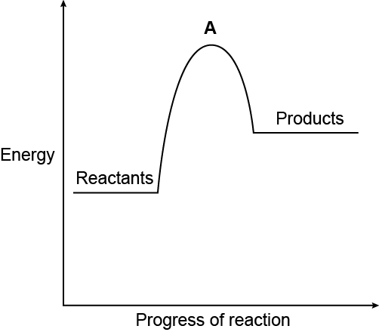
(a) | (i) | What is the type of reaction in Jill’s experiment? [1 mark]
 |  | Endothermic
 | (ii) | Why does the graph peak at A? [2 marks]
Activation energy
The energy required for a reaction to occur OWTTE
(b) | (i) | Jill does another experiment. She notices the reaction mixture gets warm. Sketch the reaction profile below for this experiment. [2 marks]
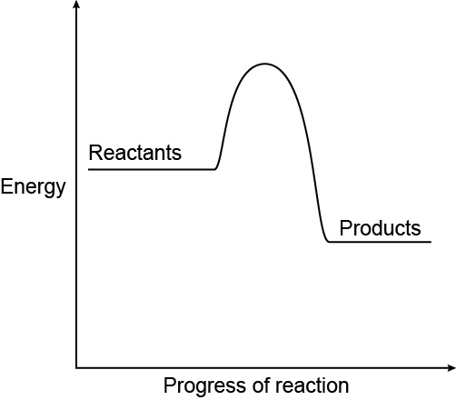
right shape
right labels
 | (ii) | How and why are endothermic and exothermic reactions different? [4 marks]
Exothermic:
Transfers energy to surroundings
More energy released when making new bonds than breaking bonds
Endothermic:
Takes in energy from the surroundings
More energy required for breaking bonds than making new bonds

- Manraj studies how iron is extracted from iron ore in his science lesson. His teacher writes this equation on the board.
Fe₂O₃ + 3CO 2Fe + 3CO₂
(a) | (i) | Define the term ‘oxidation’. [1 mark]
 |  | Gain of oxygen or loss of electrons
 | (ii) | Manraj’s teacher says there is a reducing agent in this reaction.  Which substance is the reducing agent in this reaction? What does it do?  [2 marks]
Carbon monoxide is the reducing agent
It loses/donates electrons to another (ion) (reducing the other species)
(b) | (i) | Which reactant is reduced? [1 mark]
 |  | Fe₂O₃ or Iron oxide
 | (ii) | Complete the half equation for this reaction. [1 mark]
 |  | 2Fe ³⁺ +……6…. e⁻ ……2…. Fe

- pH scales are often used in laboratories.
(a) |  | Complete the sentences. Use the words from the list below. [2 marks]  hydrogen acidity hydroxide alkalinity alkali corrosive
The pH scale is used to measure the relative …acidity….or.... alkalinity....
of a substance.
Acids form ... hydrogen... ions when they dissolve in water, and solutions of
alkalis contain ..... hydroxide..... ions.
(b) |  | Why is water formed in neutralisation reactions? [1 mark]
 |  | Hydrogen ion (from acid) react with hydroxide ions (in alkalis) to form water
(c) |  | A bottle is labelled as concentrated acid and has a hazard symbol on it.  What does the term ‘concentrated’ mean? [1 mark]
 |  | The amount of acid compared to the volume of the solution

- The picture shows electrolysis of sodium chloride solution.
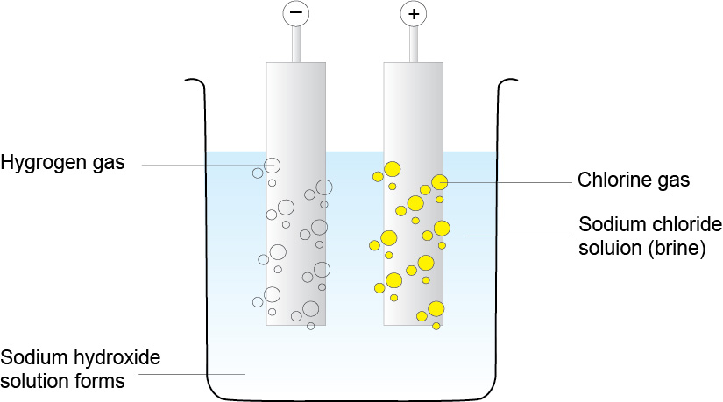
(a) | (i) | The electrolysis reaction above uses inert electrodes. What does ‘inert’ mean?  [1 mark]
 |  | Unreactive
 | (ii) | At which electrode do the cations form? [1 mark]
 |  | Cathode/negative electrode
(b) | (i) | What are the products of electrolysis of sodium chloride solution? [3 marks]
Chlorine gas
Hydrogen (gas)
Sodium hydroxide
 | (ii) | In electrolysis, what happens at each electrode? [2 marks]
Cathode:
Positive ions gain electrons/are reduced
Anode:
Negative ions lose electrons/are oxidised

- Neutralisation can be used to produce salts.
Sodium hydroxide and sulfuric acid react together to produce sodium sulfate.
(a) |  | Complete the balanced symbol equation. [1 mark]
 |  | ...2... NaOH + H₂SO₄ .. Na₂SO₄... + 2H₂O
(b) |  | What is mass sodium hydroxide needed to make 25.0g of sodium sulfate?  [3 marks]  Use the periodic table to help you.
M_{r} of Na₂SO₄ =142.1
and
M_{r} of NaOH = 40.0
Amount of NaOH needed = (25.0 ÷ 142.1) × 2 × 40.0
= 14.1

- Combustion is another type of chemical reaction. Hydrogen can be oxidised by combustion.
Bond | Bond Energy (kJ/mol)
H-H | 426
O=O | 495
H-O-H | 920

(a) |  | Using the bond energies in the table above, show that the oxidation of hydrogen is exothermic. [3 marks]
Energy to break bonds:
(2 × 426) + 495= -1347 kJ/mol
Energy to make bonds:
2 × 920 = +1840 kJ/mol
Energy of the reaction:
-1347+1840 = (+)493 kJ/mol
OCR Resources: the small print
OCR’s resources are provided to support the delivery of OCR qualifications, but in no way constitute an endorsed teaching method that is required by the Board, and the decision to use them lies with the individual teacher. Whilst every effort is made to ensure the accuracy of the content, OCR cannot be held responsible for any errors or omissions within these resources.
© OCR 2016 - This resource may be freely copied and distributed, as long as the OCR logo and this message remain intact and OCR is acknowledged as the originator of this work.
OCR acknowledges the use of the following content: n/a
Please get in touch if you want to discuss the accessibility of resources we offer to support delivery of our qualifications: resources.feedback@ocr.org.uk

We’d like to know your view on the resources we produce. By clicking on ‘Like’ or ‘Dislike’ you can help us to ensure that our resources work for you. When the email template pops up please add additional comments if you wish and then just click ‘Send’. Thank you.
If you do not currently offer this OCR qualification but would like to do so, please complete the Expression of Interest Form which can be found here: www.ocr.org.uk/expression-of-interest
Looking for a resource? There is now a quick and easy search tool to help find free resources for your qualification:
www.ocr.org.uk/i-want-to/find-resources/

This formative assessment resource has been produced as part of our free GCSE teaching and learning support package. All the GCSE teaching and learning resources, including delivery guides, topic exploration packs, lesson elements and more are available on the qualification webpages.
If you are looking for examination practice materials, you can find the Sample Assessment Materials (SAMs) on the qualification webpage: Combined Science A (9–1).

End of topic quiz

Topic C3: Chemical Reactions

Learner Activity

Topic: C3 of J250
Total marks: 43

- Calcium forms Ca²⁺ ions. What is the formula of calcium chloride? [1 mark]
A | CaCl
B | CaCl₂
C | Ca₂Cl
D | Ca₂Cl₂
Your answer

- Which statement best describes neutralisation? [1 mark]
A | An acid reacting with an alkali and a salt to form water.
B | An acid reacting with water and a salt to form an alkali or base.
C | An acid reacting with an alkali or base to form a salt plus water.
D | An acid reacting with a salt to form an alkali or base.
Your answer

- What is the correct formula for sodium chloride? [1 mark]
A | Na₂Cl₂
B | NaCl₂
C | Na₂Cl
D | NaCl
Your answer

- Which of the following is an ionic compound? [1 mark]
A | Ammonia
B | Carbon dioxide
C | Magnesium Oxide
D | Methane
Your answer

- What are the symbols s, l, g and aq used to describe? [1 mark]
A | Chemical properties
B | Elements
C | Physical states
D | Molecules
Your answer

- Bill weighs a piece of magnesium. He then heats it in air, where it reacts with oxygen. Bill weighs the product of the reaction.
(a) | (i) | What are the chemical symbols for magnesium and oxygen? [1 mark]
 |  | Magnesium
 |  | Oxygen
 | (ii) | Write a balanced symbol equation for the reaction of magnesium with oxygen.  [1 mark]
(b) | (i) | How much product is made if 5.0g of magnesium reacts with 5.0 g of oxygen?  [4 marks]  Give your answer to 2 significant figures.

- Jill mixes ethanoic acid and sodium carbonate together. She measures the temperature of the reaction and draws a graph of the energy against progress of reaction.
(a) | (i) | What is the type of reaction in Jill’s experiment? [1 mark]
 | (ii) | Why does the graph peak at A? [2 marks]
(b) | (i) | Jill does another experiment. She notices the reaction mixture gets warm. Sketch the reaction profile below for this experiment. [2 marks]
 | (ii) | How and why are endothermic and exothermic reactions different? [4 marks]

- Manraj studies how iron is extracted from iron ore in his science lesson. His teacher writes this equation on the board.
Fe₂O₃ + 3CO 2Fe + 3CO₂
(a) | (i) | Define the term ‘oxidation’. [1 mark]
 | (ii) | Manraj’s teacher says there is a reducing agent in this reaction.  Which substance is the reducing agent in this reaction? What does it do?  [2 marks]
(b) | (i) | Which reactant is reduced? [1 mark]
 | (ii) | Complete the half equation for this reaction. [1 mark]
 |  | 2Fe ³⁺ +………. e⁻ ………. Fe

- pH scales are often used in laboratories.
(a) |  | Complete the sentences. Use the words from the list below. [2 marks]  hydrogen acidity hydroxide alkalinity alkali corrosive
The pH scale is used to measure the relative …………….….or.........................
of a substance.
Acids form ....................... ions when they dissolve in water, and solutions of
alkalis contain ......................... ions.
(b) |  | Why is water formed in neutralisation reactions? [1 mark]
(c) |  | A bottle is labelled as concentrated acid and has a hazard symbol on it.  What does the term ‘concentrated’ mean? [1 mark]

- The picture shows electrolysis of sodium chloride solution.
(a) | (i) | The electrolysis reaction above uses inert electrodes. What does ‘inert’ mean?  [1 mark]
 | (ii) | At which electrode do the cations form? [1 mark]
(b) | (i) | What are the products of electrolysis of sodium chloride solution? [3 marks]
 | (ii) | In electrolysis, what happens at each electrode? [2 marks]

- Neutralisation can be used to produce salts.
Sodium hydroxide and sulfuric acid react together to produce sodium sulfate.
(a) |  | Complete the balanced symbol equation. [1 mark]
 |  | ..........NaOH + H₂SO₄ ……………... + 2H₂O
(b) |  | What is mass sodium hydroxide needed to make 25.0g of sodium sulfate?  [3 marks]  Use the periodic table to help you.
- Combustion is another type of chemical reaction. Hydrogen can be oxidised by combustion.
Bond | Bond Energy (kJ/mol)
H-H | 426
O=O | 495
H-O-H | 920

(a) |  | Using the bond energies in the table above, show that the oxidation of hydrogen is exothermic. [3 marks]

