# End of topic quiz

# Topic B4: Community Level Systems

## Learner Activity

### Topic: B4 of J250

**Total marks: 40**

1. Which term is used to describe a group of individuals of the same species? **[1 mark]**

|  |  |  |
| --- | --- | --- |
| **A** | Community |  |
| **B** | Ecology |  |
| **C** | Habitat |  |
| **D** | Population |  |

Your answer

1. Which process removes carbon dioxide from the air? **[1 mark]**

|  |  |  |
| --- | --- | --- |
| **A** | Combustion |  |
| **B** | Decomposition |  |
| **C** | Photosynthesis |  |
| **D** | Respiration |  |

Your answer

1. What is an ecosystem? **[1 mark]**

|  |  |  |
| --- | --- | --- |
| **A** | A community of interdependent organisms and the environment in which  they live. |  |
| **B** | The living organisms which coexist in a habitat. |  |
| **C** | The part of the Earth which contains living organisms. |  |
| **D** | The producers and consumers in an environment. |  |

Your answer

1. The kite diagram shows the distribution of a species of invertebrates living in a stream.

0 2 4 6 8 10 12

Distance downstream (m)

How far down the stream was the highest number of invertebrates? **[1 mark]**

|  |  |  |
| --- | --- | --- |
| **A** | 3 m |  |
| **B** | 6 m |  |
| **C** | 8 m |  |
| **D** | 12 m |  |

Your answer

1. Which of the following is a biotic factor? **[1 mark]**

|  |  |  |
| --- | --- | --- |
| **A** | Availability of food |  |
| **B** | Moisture level |  |
| **C** | pH of soil |  |
| **D** | Temperature |  |

Your answer

1. The diagram shows part of a food web for an African plain.

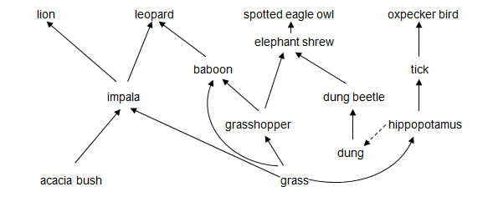

|  |  |  |  |  |
| --- | --- | --- | --- | --- |
| **(a)** |  | The diagram shows part of a community.  What is a community? **[1 mark]** | | |
|  |  |  | | |
|  |  |  |  | |
| **(b)** | **(i)** | The tick is a parasite.  What is a parasite? **[1 mark]** | | |
|  |  |  | | |
|  |  |  |  | |
|  | **(ii)** | Oxpeckers live on the back of hippopotamus.  What is the ecological relationship between the oxpecker and the hippopotamus? **[3 marks]** | | |
|  |  |  | | |
| **(c)** | **(i)**  **(ii)** | The baboon is an omnivore.  Why is being an omnivore an advantage when there is a low number of grasshoppers? **[1 mark]** | |  |
|  | |
| Why is a shortage of grass a greater problem than a low number of grasshoppers? **[1 mark]** | |
|  | |

|  |  |  |  |
| --- | --- | --- | --- |
|  |  |  |  |
| **(d)** |  | Leopard and lion are competitors.  Both are hunted by humans.  If the number of leopards falls due to hunting.  What will happen to the population of: | |
|  | **(i)** | Lion?**[1 mark]** | |
|  |  |  | |
|  |  |  | |
|  | **(ii)** | Impala? **[1 mark]** | |
|  |  |  | |
|  |  |  | |
|  | **(iii)** | Hippopotamus? **[1 mark]** | |
|  |  |  | |
|  |  |  |  |

|  |  |  |  |  |  |  |  |  |  |  |  |  |  |  |
| --- | --- | --- | --- | --- | --- | --- | --- | --- | --- | --- | --- | --- | --- | --- |
| **(e)** |  | The number of dung beetles can be monitored using a capture-mark-recapture method of sampling.  The number of dung beetles can be estimated using this formula:   |  |  | | --- | --- | | population size = | number in 1st sample × number in 2nd sample | | number in 2nd sample previously marked |   The sampling data is shown in the table below.   |  | 1st sample | 2nd sample | | --- | --- | --- | | number in sample | 100 | 120 | | number marked in sample |  | 30 | |
|  |  |  |
|  | **(i)** | Use the formula to estimate the number dung beetles. **[2 marks]** |
|  |  |  |
|  |  |  |
|  | **(ii)** | Why might this number not be accurate? **[2 marks]** |
|  |  |  |
|  |  |  |
|  | **(iii)** | Dung beetles are detritivores.  Detritivores feed on waste matter.  They break down organic material. This process is similar to decomposition.  Use the food web and your own knowledge to explain why this is an important role. **[2 marks]** |
|  |  |  |

1. In many ecosystems abiotic factors change from one place to another.

The table below shows abiotic factors in a tropical rainforest, going from the ground up to the tops of the trees.

| **distance from ground (m)** | **0** | **5** | **10** | **15** | **22** | **30** |
| --- | --- | --- | --- | --- | --- | --- |
| light intensity (%) | 2 | 3 | 8 | 15 | 50 | 70 |
| wind speed (km/h) | 0 | 3 | 5 | 9 | 12 | 15 |
| humidity (%) | 98 | 90 | 85 | 80 | 75 | 67 |

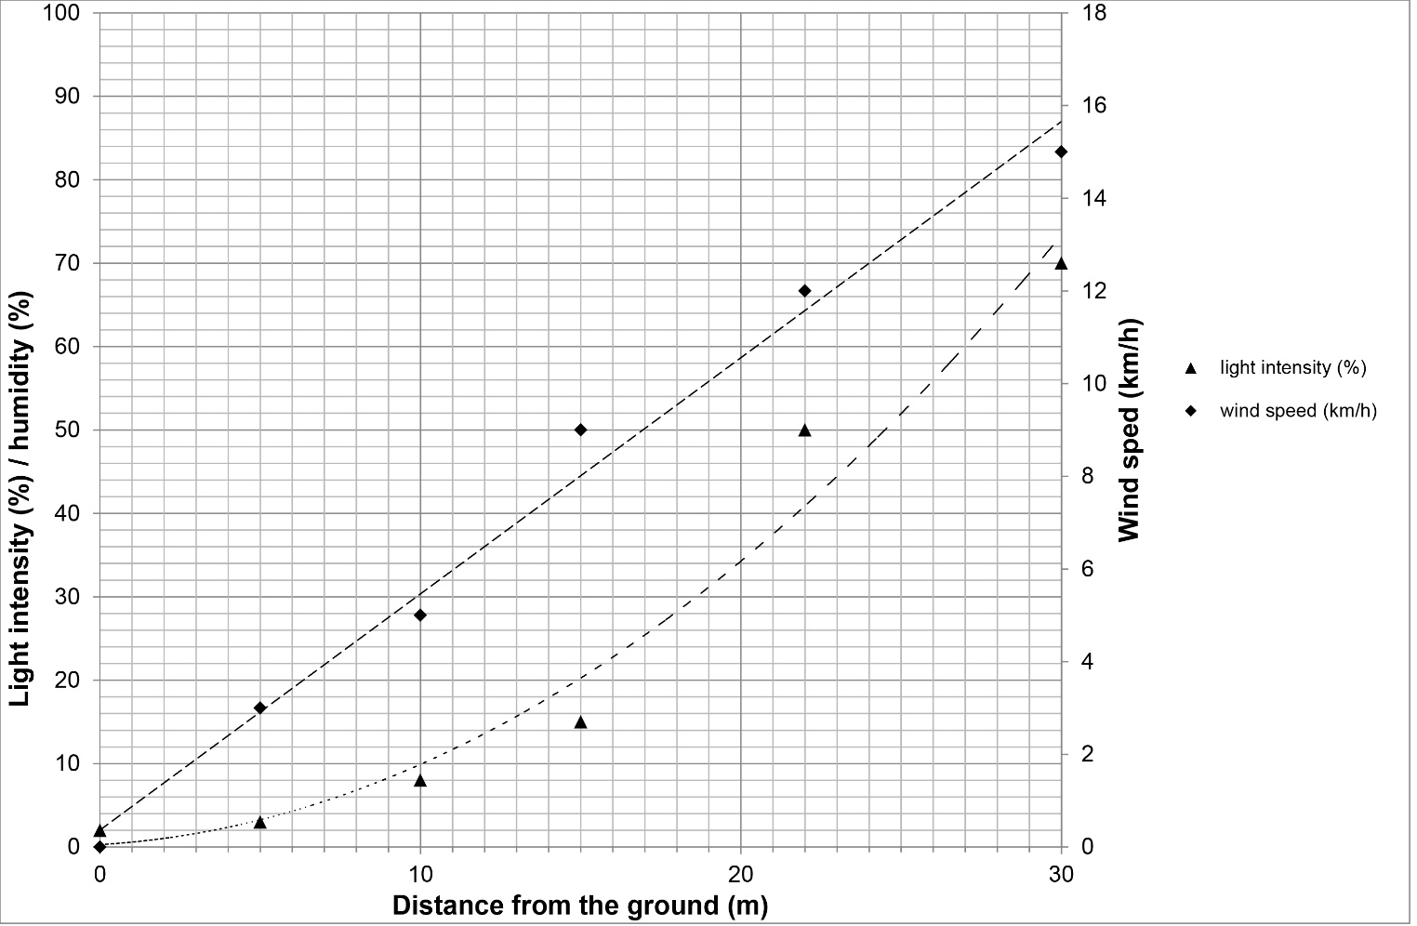

|  |  |  |  |
| --- | --- | --- | --- |
| **(a)** |  | Plot, using the left hand axis, the data for humidity.  Draw a curved line through the points. **[3 marks]** | |
|  |  |  |  |

|  |  |  |  |
| --- | --- | --- | --- |
| **(b)** |  | What trends and patterns are shown in the graph? **[3 marks]** | |
|  |  |  | |
|  |  |  |  |
| **(c)** |  | Name one advantage and one disadvantage for plants growing near the ground in the forest. **[2 marks]**  Use the data and your own knowledge to help you. | |
|  |  | **Advantage:**  **Disadvantage:** | |
|  |  |  |  |
| **(d)** |  | Forests are an important part of both the water cycle and the carbon cycle.  Forests are being cut down and cleared.  What are the possible consequences of this disruption of the water and carbon cycles? **[3 marks]** | |
|  |  |  | |

1. Different materials cycle through ecosystems.

The diagram shows the nitrogen cycle.

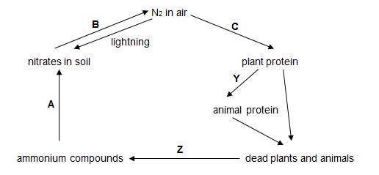

|  |  |  |  |
| --- | --- | --- | --- |
| **(a)** |  | What are processes **Y** and **Z**? **[2 marks]** | |
|  |  |  | |
|  |  |  |  |
| **(b)** | **(i)** | In which stage, **A**, **B** or **C**, is nitrogen moved from an abiotic to a biotic component of the ecosystem? **[1 mark]** | |
|  |  |  | |
|  |  |  |  |
|  | **(ii)** | Microorganisms are involved at stages **A**, **B,** **C** and **Z.**  What is the role of microorganisms in the cycling of nitrogen? **[2 marks]** | |
|  |  |  | |
|  |  |  |  |
| **(c)** |  | Sometimes the microorganisms at **C** are in a mutualistic relationship with the plants.  The microorganisms live in root nodules on the plants.  How could the relationship be beneficial to both the plant and microorganism?  **[2 marks]** | |
|  |  |  | |
|  |  |  |  |
| **(d)** |  | Humans affect the nitrogen cycle by applying large amounts of nitrogen fertiliser.  This increases the level of nitrates in the soil.  Why do humans apply fertiliser? **[1 mark]** | |
|  |  |  | |