End of topic quiz

Topic P2: Forces

Instructions and answers for teachers
These instructions cover the learner activity section which can be found on page 9. This end of topic quiz supports OCR GCSE (9–1) Combined Science A (J250), Topic P2.
When distributing the activity section to the learners either as a printed copy or as a Word file you will need to remove the teacher instructions section.

The Activity
This end of topic quiz is a teaching and learning resource comprised of 40 marks covering a range of question types. The quiz starts with some multiple choice questions (MCQs) and then moves on to some short answer questions and then finally on to some longer answer questions.
This resource can be used to test and consolidate understanding at the end of teaching the topic or to revisit and refresh knowledge at a later point in the course.

Learning Outcomes
This end of topic quiz relates to the specification learning outcomes in Topic P2: Forces. The questions in this quiz cover a range of the following topics:
P2.1 Motion
P2.2 Newton’s laws
P2.3 Forces in action

Topic: P2 of J250 - Answers
Total marks: 40

- A car travels 10 km in 1 hour, what is his average speed? [1 mark]
A | 0.002 m/s
B | 0.17 m/s
C | 2.8 m/s
D | 166.7 m/s
Your answer
C
- Which of the following are scalar quantities? [1 mark]
A: Distance
B: Displacement
C: Speed
D: Velocity
A | A and B
B | B and C
C | C and D
D | A and C
Your answer
D

- What is the work done in pushing a 5 kg bag half a metre across a desk? [1 mark]
A | 2.5 J
B | 5.0 J
C | 25 J
D | 49.1 J
Your answer
C
- Which of the following planets has the greatest gravitational field strength? [1 mark]
A | Earth
B | Jupiter
C | Mercury
D | Pluto
Your answer
B
- A 500 g ball is lifted 20 m up from the surface of Earth. What is its gravitational potential energy? [1 mark]
A | 10 J
B | 100 J
C | 10000 J
D | 98000 J
Your answer
B

- A car of mass 1000 kg accelerates from 5 m/s to 30 m/s over a distance of 20 m.

(a) |  | What is its acceleration? Give the correct unit. [4 marks]
acceleration = (final velocity)² – (initial velocity)² ÷ (2 x distance) ✓
(30² – 5²) ÷ (2 x 20) ✓
= 21.9✓
m/s^{2✓}
(b) | (i) | What is its kinetic energy at the start? [2 marks]
1000 x 0.5 x 25✓
= 12.5 kJ✓
 | (ii) | What is its kinetic energy at the end? [1 mark]
 |  | 450 kJ✓

- Ronny wants to find out how fast Trish can run across the school field.
(a) |  | Write down what measurements Ronny should take, including what instruments they should use, and what calculations they should make in order to find an accurate value for Trish’s speed. [6 marks]
Distance she will run - using a trundle wheel/tape measure✓
Time taken - using a stopwatch✓
Repeat this at least three times✓
Discard/repeat anomalies✓
Calculate a mean✓
Use speed = distance ÷ time✓
(b) |  | Trish runs 400 m at a speed of 9 m/s. How long does she take? [1 mark]
 |  |  | 400 ÷ 9 = 44.4 s✓

- A skydiver jumps out of a plane and falls for 20 seconds. They then open their parachute and fall for another 20 seconds.

(a) |  | Write down, using Newton’s Laws of Motion, how the motion of the skydiver changes during these two periods due to the forces acting on them.  [6 marks]
0 – 20 s:
Newton’s 2nd Law tells us they accelerate downwards due to weight✓
Air resistance increases until in equilibrium with weight✓
Newton’s 1st Law tells us they remain at the speed they have reached.✓
20 - 40s:
Newton’s 2nd Law tells us they decelerate as air resistance is greater than weight✓
Air resistance decreases until in equilibrium with weight✓
Newton’s 1st Law tells us they remain at the speed they have reached.✓
(b) |  | To begin with their weight is 900N and there is negligible air resistance acting on them. What is their acceleration? Include a unit. [2 marks]
900 ÷ 10 = 90 ✓
m/s²✓
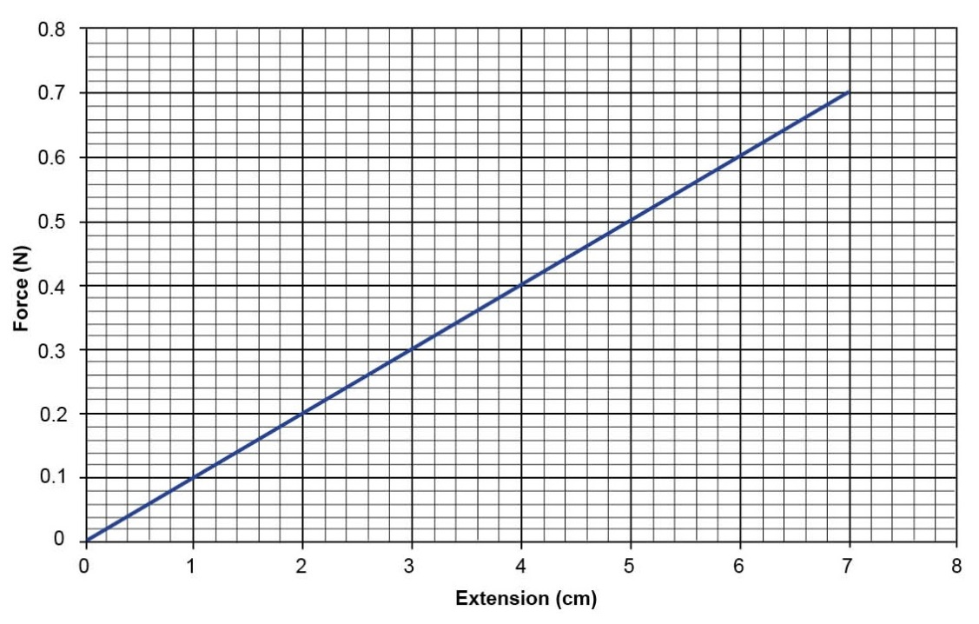

(a) | (i) | What does the term spring constant mean? [2 marks]
a value which tells us how much a specific spring will extend✓
for each newton of force applied to it.✓
 | (ii) | Using the graph above work out the spring constant for this spring. Include a unit. [3 marks]
0.2 ÷ 0.02 ✓
= 10✓
N/m✓
(b) |  | What is the energy stored in the spring when extended by 7cm? [2 marks]
0.5 x 10 x (0.07)²✓
= 0.025 J✓

- Jay carries a 5 kg mass up a flight of stairs, the stairs were 5 m in height.
(a) | (i) | How much gravitational potential energy does the mass now have?  [2 marks]
5 x 5 x 10✓
= 250 J✓
 | (ii) | Jay drops the mass. Assuming all gravitational energy is converted to kinetic energy, what is its velocity just before impact? [2 marks]
KE = GPE
v = √((2 x250) ÷ 5)✓
= 10 m/s✓
(b) |  | Jay takes 30 seconds to climb the stairs. What power was Jay using to lift the mass? [2 marks]
250 ÷ 30✓
= 8.33 W✓
OCR Resources: the small print
OCR’s resources are provided to support the teaching of OCR specifications, but in no way constitute an endorsed teaching method that is required by the Board, and the decision to use them lies with the individual teacher. Whilst every effort is made to ensure the accuracy of the content, OCR cannot be held responsible for any errors or omissions within these resources.
© OCR 2016 - This resource may be freely copied and distributed, as long as the OCR logo and this message remain intact and OCR is acknowledged as the originator of this work.
OCR acknowledges the use of the following content: Pages 6 and 16 Motion blur car gyn9037/Shutterstock.com: Pages 8 and 18 Skydiver Jaggie Botma/Shutterstock.com
Please get in touch if you want to discuss the accessibility of resources we offer to support delivery of our qualifications: resources.feedback@ocr.org.uk
We’d like to know your view on the resources we produce. By clicking on ‘Like’ or ‘Dislike’ you can help us to ensure that our resources work for you. When the email template pops up please add additional comments if you wish and then just click ‘Send’. Thank you.
Whether you already offer OCR qualifications, are new to OCR, or are considering switching from your current provider/awarding organisation, you can request more information by completing the Expression of Interest form which can be found here: www.ocr.org.uk/expression-of-interest
Looking for a resource? There is now a quick and easy search tool to help find free resources for your qualification:
www.ocr.org.uk/i-want-to/find-resources/

This formative assessment resource has been produced as part of our free GCSE teaching and learning support package. All the GCSE teaching and learning resources, including delivery guides, topic exploration packs, lesson elements and more are available on the qualification webpages.
If you are looking for examination practice materials, you can find the Sample Assessment Materials (SAMs) on the qualification webpage: Combined Science A (9-1).

End of topic quiz

Topic P2: Forces

Learner Activity

Topic: P1 of J250
Total marks: 40
- A car travels 10 km in 1 hour, what is his average speed? [1 mark]
A | 0.002 m/s
B | 0.17 m/s
C | 2.8 m/s
D | 166.7 m/s
Your answer

- Which of the following are scalar quantities? [1 mark]
A: Distance
B: Displacement
C: Speed
D: Velocity
A | A and B
B | B and C
C | C and D
D | A and C
Your answer

- What is the work done in pushing a 5 kg bag half a metre across a desk? [1 mark]
A | 2.5 J
B | 5.0 J
C | 25 J
D | 49.1 J
Your answer

- Which of the following planets has the greatest gravitational field strength? [1 mark]
A | Earth
B | Jupiter
C | Mercury
D | Pluto
Your answer

- A 500 g ball is lifted 20 m up from the surface of Earth. What is its gravitational potential energy? [1 mark]
A | 10 J
B | 100 J
C | 10000 J
D | 98000 J
Your answer

- A car of mass 1000 kg accelerates from 5 m/s to 30 m/s over a distance of 20 m.

(a) |  | What is its acceleration? Give the correct unit. [4 marks]
(b) | (i) | What is its kinetic energy at the start? [2 marks]
 | (ii) | What is its kinetic energy at the end? [1 mark]

- Ronny wants to find out how fast Trish can run across the school field.
(a) |  | Write down what measurements Ronny should take, including what instruments they should use, and what calculations they should make in order to find an accurate value for Trish’s speed. [6 marks]
(b) |  | Trish runs 400 m at a speed of 9 m/s. How long does she take? [1 mark]

- A skydiver jumps out of a plane and falls for 20 seconds. They then open their parachute and fall for another 20 seconds.
(a) |  | Write down, using Newton’s Laws of Motion, how the motion of the skydiver changes during these two periods due to the forces acting on them.  [6 marks]
(b) |  | To begin with their weight is 900N and there is negligible air resistance acting on them. What is their acceleration? Include a unit. [2 marks]

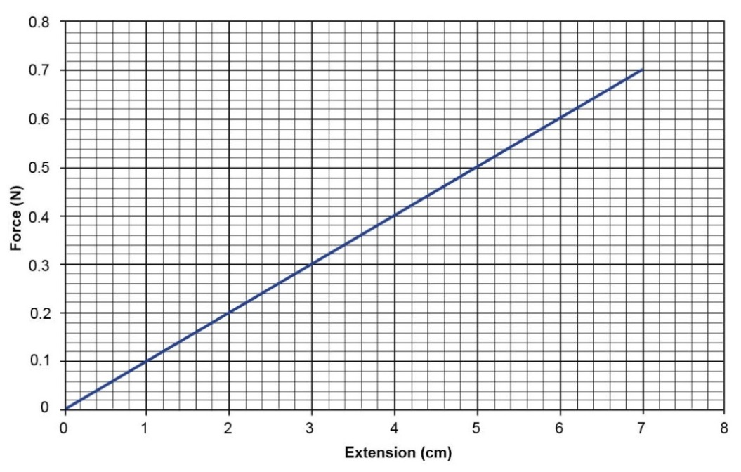

(a) | (i) | What does the term spring constant mean? [2 marks]
 | (ii) | Using the graph above work out the spring constant for this spring. Include a unit. [3 marks]
(b) |  | What is the energy stored in the spring when extended by 7cm?  [2 marks]
- Jay carries a 5 kg mass up a flight of stairs, the stairs were 5 m in height.

(a) | (i) | How much gravitational potential energy does the mass now have?  [2 marks]
 | (ii) | Jay drops the mass. Assuming all gravitational energy is converted to kinetic energy, what is its velocity just before impact? [2 marks]
(b) |  | Jay takes 30 seconds to climb the stairs. What power was Jay using to lift the mass? [2 marks]

